Ceiling Lamp

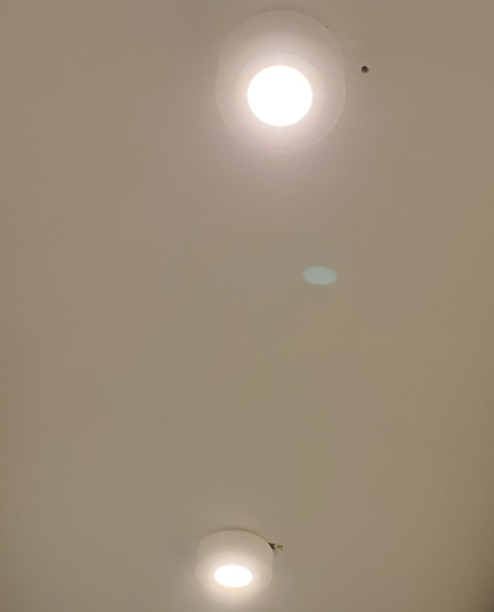

Project Goals
Create a light using a Recessed Ceiling LED Led.
The lamp is made by 2 body:
- Lamp Base: this is fixed to the wall or to the ceiling
- Lamp Case: this is the removable part where the Recessed LED Light is mounted.
The 2 body are connected with a thread, like a jar and his cap.
The resulting object is quite big the 2 part can be printed in one go.
This is the first project where I use 3D Printed threads.

Reference
These are the Recessed LED Lights I have used for the project.
https://amzn.eu/d/hiAGEYF
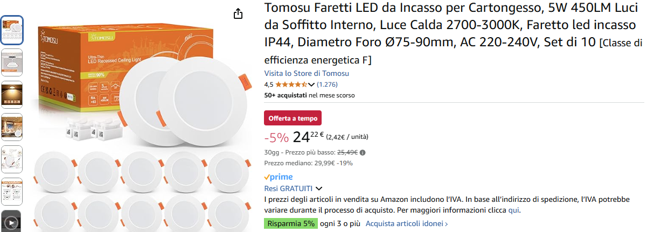

Recessed LED Lamp Size

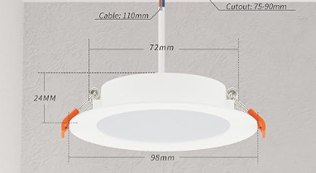

Diameter: 72 mm
Maximum diameter: 98 mm
Height: 50 mm

Drawings: Lamp Base
The outer diameter is 125 mm
The outer wall is 6 mm thick to accommodate the thread.
There are 12 slots on the side that are used to vent out the heat generated by the lamp.
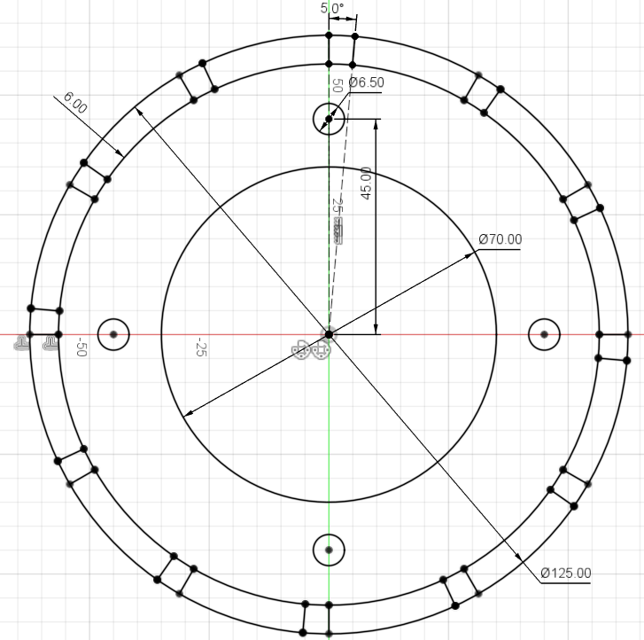

Drawings: Lamp Case
This is the case for the recessed LED light.
The maximum external diameter is 140 mm
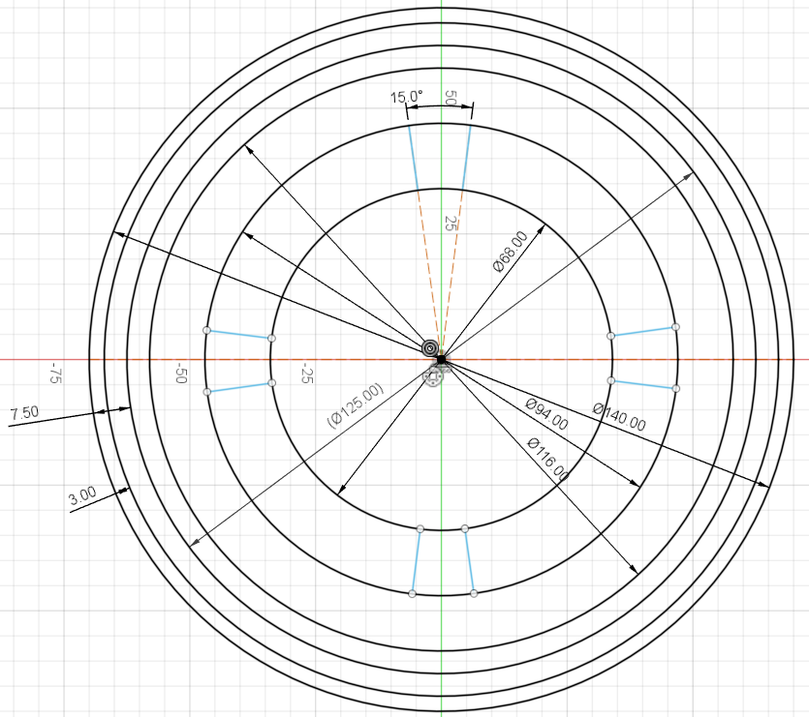

3D Model: Lamp Base
The base thickness is 3 mm. The big hole in the center is used to accommodate the plastic tube with wires.
The wall height is 25 mm
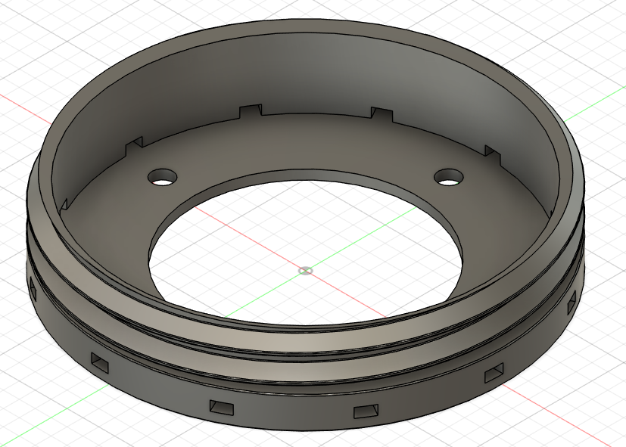

Side wall thread
The side thread is metric, 15 mm high and M125x8 mm.
In order to have a smooth coupling, the thread surface are recessed by 0.2 mm.
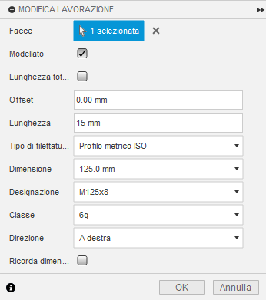

This is how the thread looks like using an section inspection.
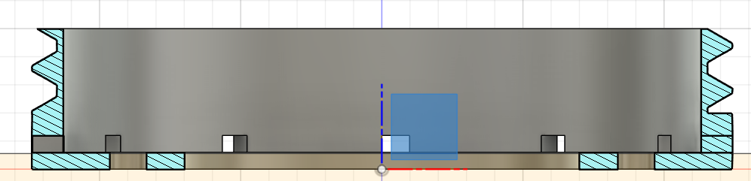

3D Model Lamp Case
Extrusion:
- Base 3 mm
- Body 5 mm
There are 4 parts that moves from outside to inside and are used to keep the recessed LED centered.
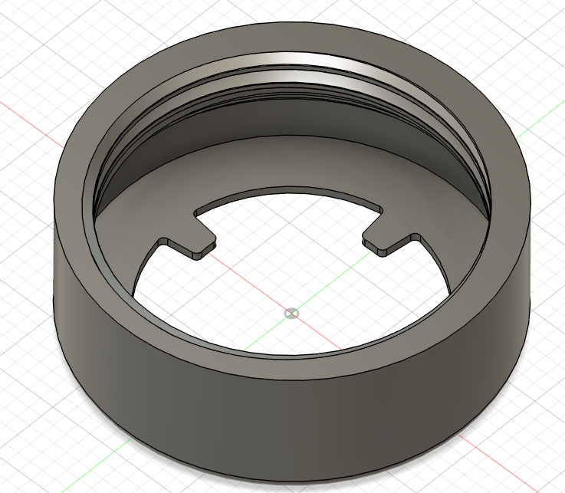

Threads
0,3 for Fillet and for offset of all faces of the male thread
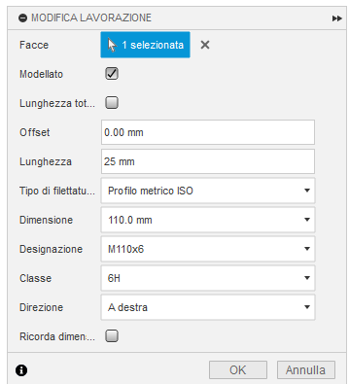

3D Printing

Export configuration
To achieve a good print quality it is mandatory to configure the export dialog for a high level of refinement.
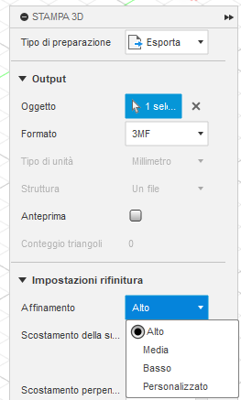

Ready to print layout
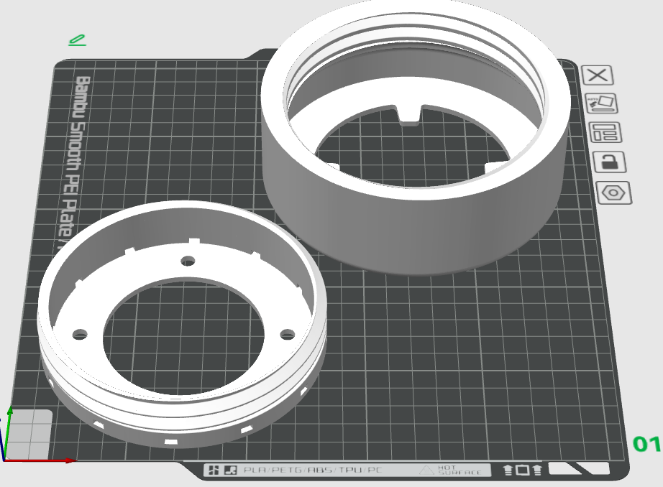

Appendix

Reference about using Fusion 360 and Threads
https://www.youtube.com/watch?v=aGWrFeu8Hv0
3D Printed Threads - Model Them in Fusion 360 | Practical Prints #2

